|  |  |  |
| --- | --- | --- |
| x | 0110 0010 | 1010 0010 |
| **<<** 3 | 0001 0000 | 0001 0000 |
| log. **>>** 2 | 0001 1000 | 0010 1000 |
| arith. **>>** 2 | 0001 1000 | 1110 1000 |

|  |
| --- |
| **Logical Operators** – returns bool &&, ||, !  (!! returns 1 if anything but 0) |

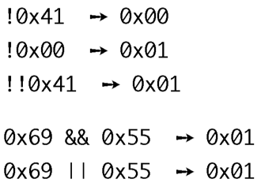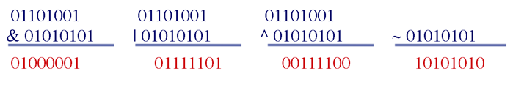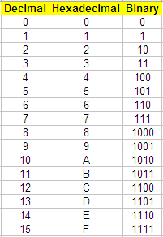CC: ZF – zero. SF – negative.



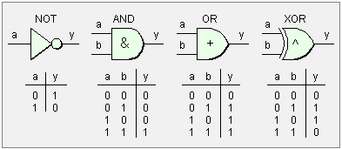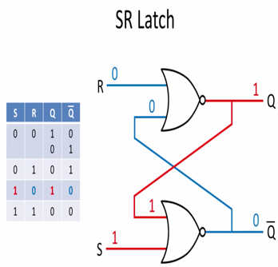

Multiplexer – essentially a switch









>>> 



